VOCA – Challenges and Bridging the Gap

VOCA – Victims of Crime Act –
- Established the Crime Victims Fund (CVF)
- Funded by monetary penalties assessed against people and entities that violate federal law
- Bulk of the deposits come from white collar crime
- Victim assistance - largest source of government funding for victim services, including CACs
- Victim compensation - provides matching funds for state victim compensation funds

How does VOCA work?
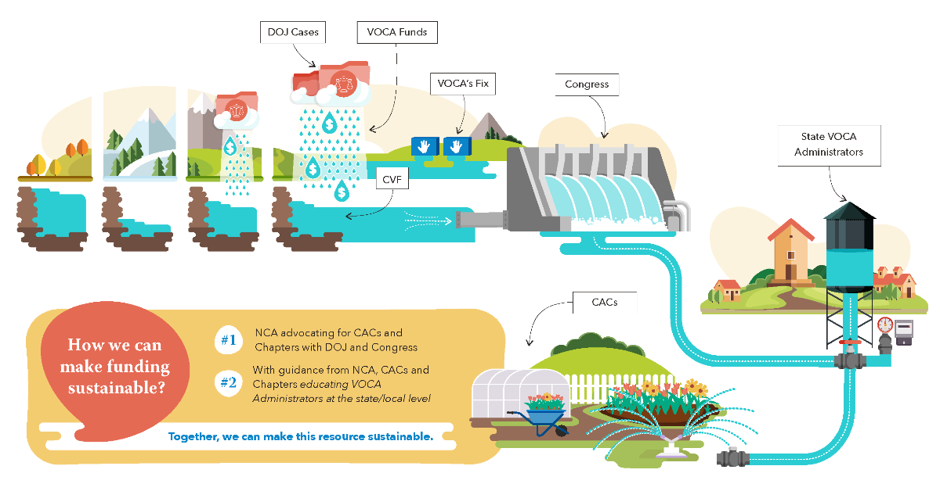

- In recent years, the fines flowing into the Fund have not kept pace with the dollars being released to the field, thus the overall balance in the CVF has almost been depleted.

- In an effort to address the VOCA crisis, Congress passed and President Biden signed the VOCA Fix Act in July 2021. (This bill overwhelmingly passed the House in March of 2021, and unanimously passed the Senate in July.)

VOCA Fix
- Directs all dollars collected from DOJ criminal prosecution/deferred prosecution/non-prosecution agreements into the Crime Victims Fund.
- Requires VOCA Administrators to waive the 20% match requirement and requires state VOCA Administrators to develop and publish a policy and procedure for obtaining a waiver.

What VOCA Fix Did and Did not do:
- DID –
  - Add a new source of revenue for CVF
  - Increase State compensation programs
  - Gave AG authority for no-cost extensions
  - Allowed states to waive match requirements
- DID NOT –
  - Change the budgeting process or timeline
  - Set annual disbursement
  - Create a foolproof solution that always ensures substantial funding

VOCA Fix – How it’s working
- Dollars are flowing into the Fund, but there is still a long way to go.
- The future of how much we can expect to be added to replenish the Crime Victims Fund (CVF), and how much will be available each year is uncertain.
- US attorneys at DOJ working on federal criminal cases are ultimately who determine how much funding goes into CVF, and Congressional appropriators are ultimately the ones who determine how much is released from it.
- VOCA administrators may withhold releasing available funds to protect against future cuts or uncertainty.

VOCA – What we can do
- Continue partnering with VOCA stakeholders to work with DOJ and Congress to explore all options with VOCA, and ensure that all parties understand the impacts of funding cuts, interruptions, and uncertainty on our services to children and families.
- Continue to check in regularly with state VOCA administrators about where the state funding stands, and to encourage them to release as much as possible for CACs.
- Work with your statewide coalition of victim services agencies to ensure that as much VOCA funding as possible reaches all victim service agencies.
- Reach out to your contacts to assist in the push to increase funding released to victim service agencies, increase funding deposited into CVF, and work with statewide partners whose interests align with ours to do the same.
- Continue to urge state lawmakers on accessing ARPA funds or other possible sources for bridge funding.

