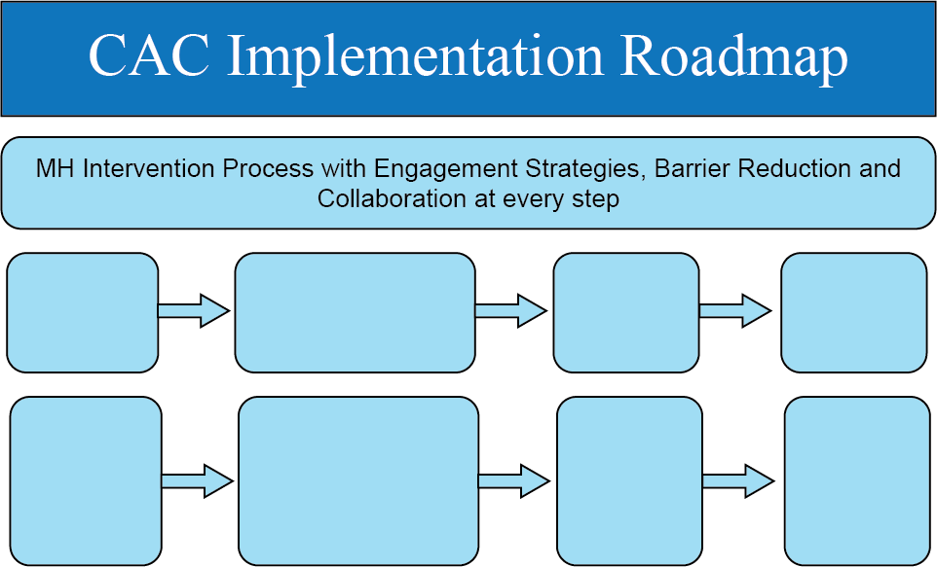
INSTRUCTIONS: Fill out the Map to reflect the MH process at your CAC
Type your content here…
Type your content here…
Type your content here…
Type your content here…
Type your content here…
Type your content here…
Type your content here…
Type your content here

