VOCA Fix – One pager
VOCA Background:
- VOCA grants are the primary source of federal funding for CACs and thousands of victim service providers
- VOCA grants also fund victim compensation
- VOCA grants are not taxpayer-funded. Instead, they are paid for out of the Crime Victims Fund (“CVF” or “the Fund”), which comprises federal criminal monetary penalties

Current Funding Crisis:
- In Fiscal Year 2020, the VOCA disbursement - and thus the funding available for victim service providers - decreased by 25%, and victim service providers are being told of further, potentially catastrophic cuts.
- The past and expected future cuts to VOCA grants are the result of concerningly low deposits into the Fund.
- As the size of the Fund dwindles, less money is available to be disbursed to the states in the form of grants.
- Instead of seeking convictions in federal crimes, particularly white collar crimes, DOJ is increasingly relying on non-prosecution and deferred-prosecution agreements. If these cases had been prosecuted, the monetary penalties would have been deposited into the Fund. Instead, the money that would otherwise go to serve victims is being deposited into the General Treasury.

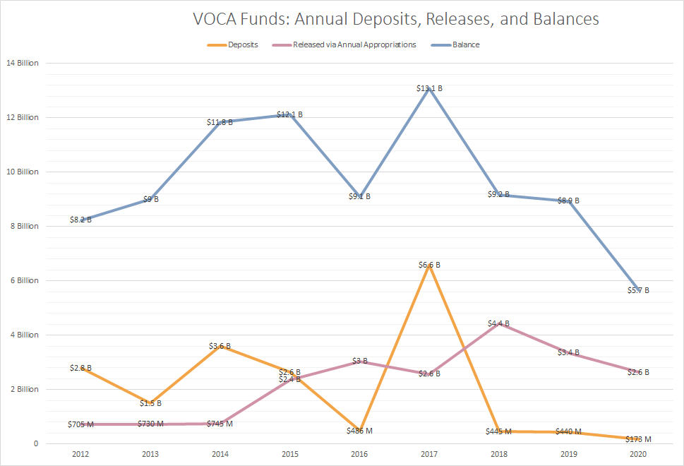

Solution – Immediately Pass the VOCA Fix! This bill will:
- Redirect monetary penalties from federal deferred prosecution and non-prosecution agreements that would otherwise be deposited into the General Treasury into the Crime Victims Fund;
- Provide additional funds for funding to victim compensation programs;
- Allow states to request a no-cost extension from the Attorney General to ensure states can thoughtfully and effectively distribute victim service grants without being penalized.

This bill will also:
- Require state VOCA Administrators to waive the 20% match requirement during the pandemic + 1 year;
- Allow state VOCA Administrators to waive subgrantee match requirements at their discretion after the aforementioned waiver expires, and require state VOCA Administrators to develop and publish a policy and procedure for obtaining a waiver;
- Provide flexibility for state compensation programs to waive the requirement to promote victim cooperation with law enforcement if good cause is established by the program.

Immediately passing the VOCA Fix is critical. Every day that passes without the fixes above is a day that money that, with these fixes, could be accruing into the CVF is not doing so - as much as $2 billion annually. (Already this year, 2 cases settling with more than $400M were lost to the CVF, and instead, the money was directed to the General Treasury.)

